Software Project Documentation
Project Title:
Foot Lab Camera Website
Prepared By:
Mustafa 1705517
Afzal Khan 1704964
Tihami 1706353
Course / Institute:
Advance Diploma In Software Engineering / Aptech Learning
Introduction:
The thirst for learning, upgrading technical skills and applying the concepts in real
life environment at a fast pace is what the industry demands from IT professionals
today. However busy work schedules, far-flung locations, unavailability of convenient
time-slots pose as major barriers when it comes to applying the concepts into
realism. And hence the need to look out for alternative means of implementation in
the form of laddered approach.
The above truly pose as constraints especially for our students too! With their busy
schedules, it is indeed difficult for our students to keep up with the genuine and
constant need for integrated application which can be seen live especially so in the
field of IT education where technology can change on the spur of a moment. Well,
technology does come to our rescue at such times!!
Keeping the above in mind and in tune with our constant endeavour to use
Technology in our training model, we at Aptech have thought of revolutionizing the
way our students learn and implement the concepts using tools themselves by
providing a live and synchronous e-project learning environment!
Problem Statement:
FOTOLAB was established in 1991 with the objective of providing sales service for
Digital Camera, SLR Camera, Handy cam, their accessories and all other related
products.
They allot top priority to innovation &amp; upgradation of technology in the avenues of
Distribution of All kinds and brands of Digital Camera and their related accessories.
The customers get the benefit of Undivided Attention, Expert Analysis, Innovative
Ideas, Commitment and Comprehensive Hardware &amp; Software Solution.
You are supposed to create a website for them with the below mentioned
requirement specifications.
The website is to be developed for the Windows Platform using HTML5, JavaScript
and Geolocation. The site should work well in all leading browsers including Chrome,
IE, Firefox etc.
Objectives Of The Project:
The Objective of this program is to give a sample project to work on real life
projects. These applications help you build a larger more robust application.
The objective is not to teach you HTML/JavaScript/Dreamweaver/HTML5 but to
provide you with a real life scenario and help you create basic applications using the
tools.
You can revise the chapters before you start with the project.
This project is meant for students who have completed the module of
Dreamweaver. These programs should be done in the Lab sessions with assistance
of the faculty if required.
It is very essential that a student has a clear understanding of the subject. Students
should go through the project and solve the assignments as per requirements given.
Kindly get back to e-projects Team in case of any doubts regarding the application or
its objectives.
Requirements Specifications:
- The Home Page should be created making use of Sections with a suitable logo, the header section can be added which will show images of related products.
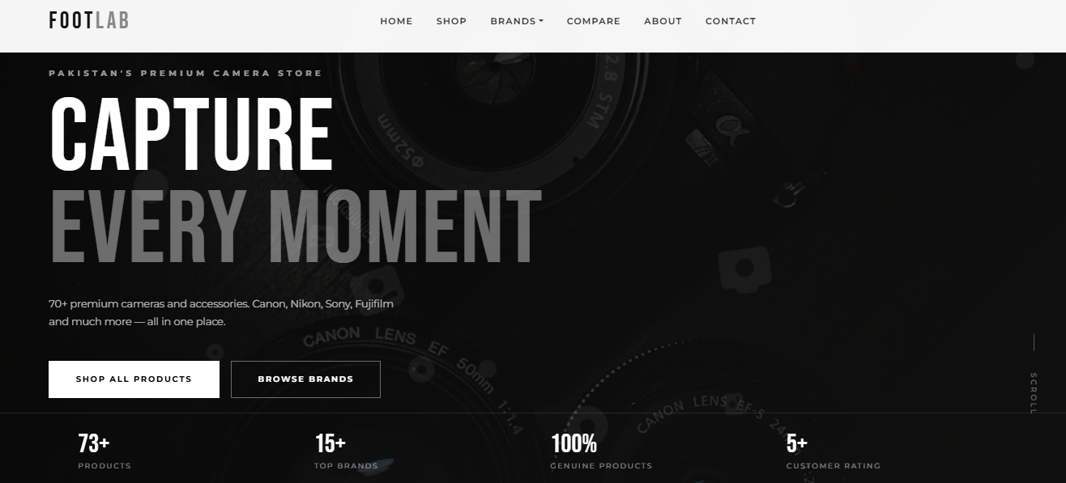
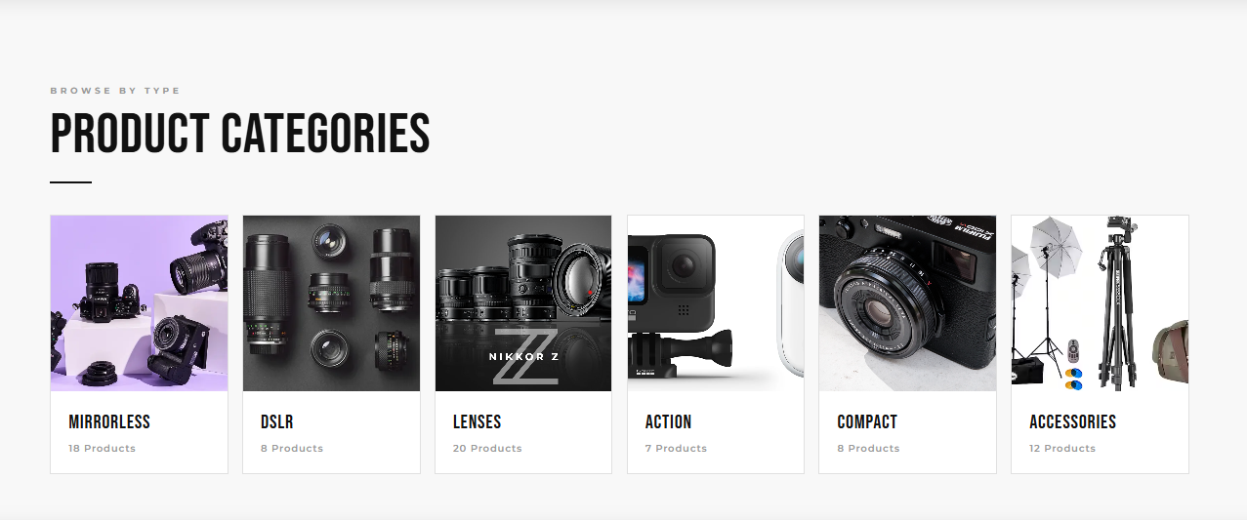
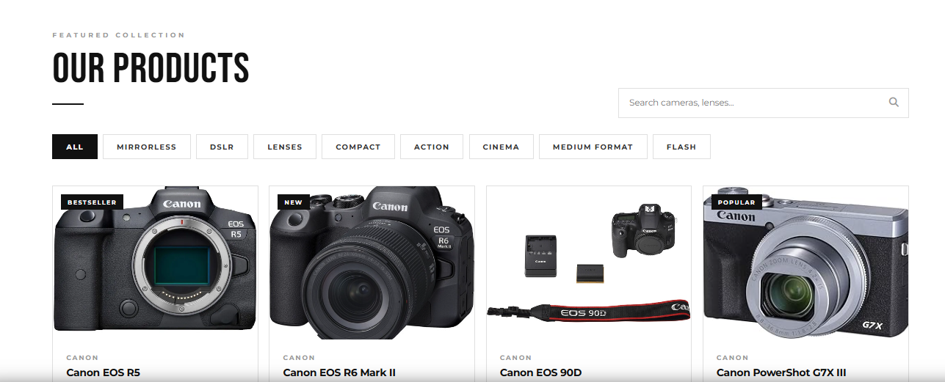
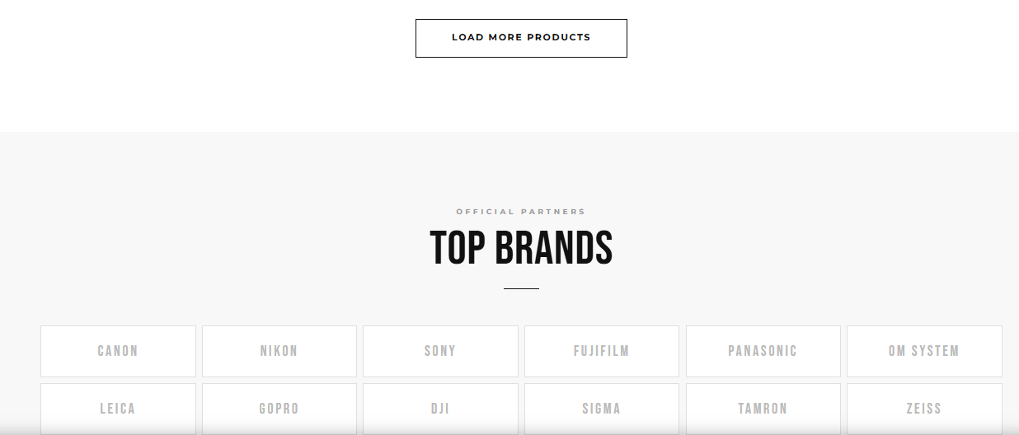
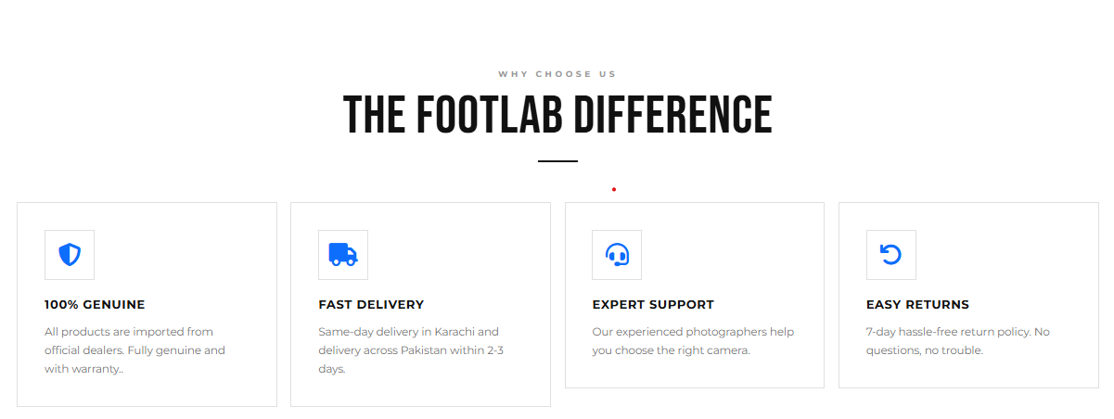
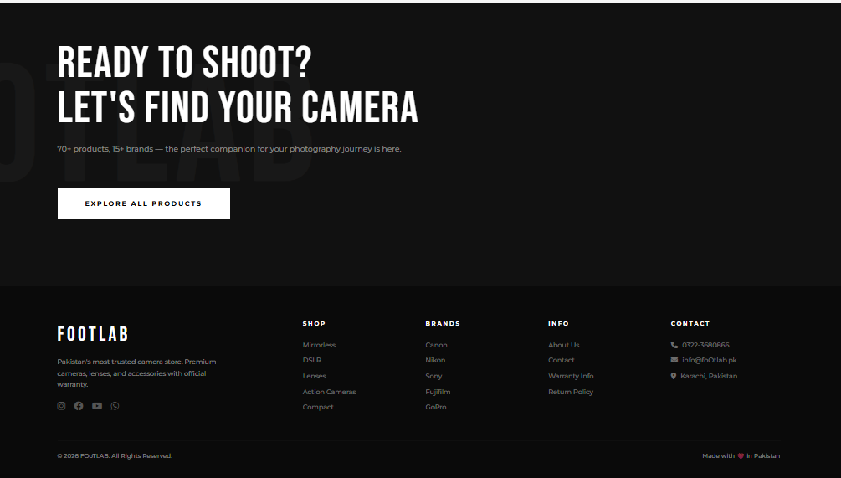
- The site must contain the links to navigate through any category for the information.
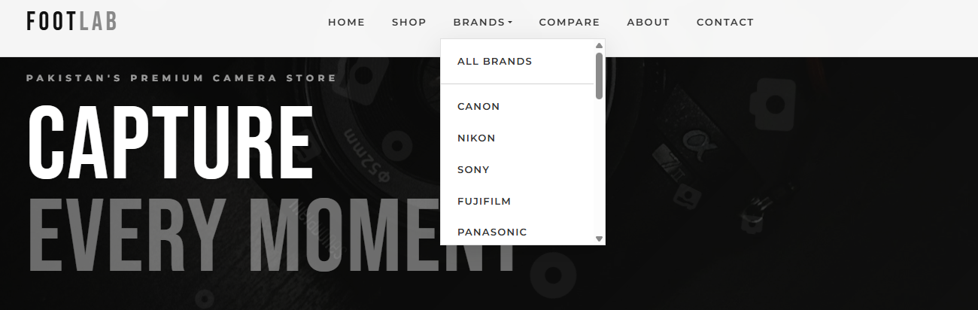
- The site should display a menu which will have categories of all products.
Few products expected to be included are mentioned below, however more can be added.
- Cameras: all types of cameras should be included
- Camera lenses: varieties of lenses to be included
- Pro audio: related audio accessories options to be included
- Memory cards & media: related products
- Tripods & supports
- Lighting & Studio
- Camera bags & cases
- Miscellaneous accessories
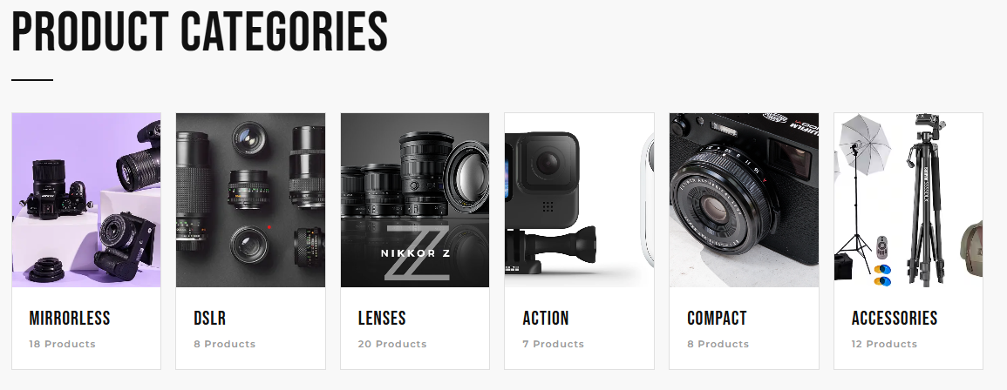
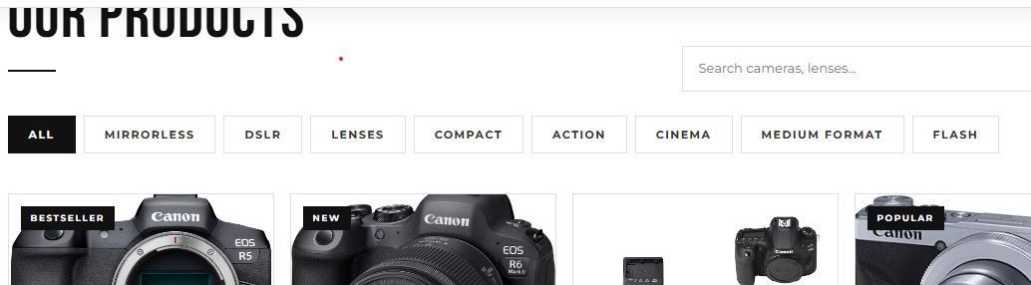
- The site should contain the options for brief introduction about the various products available, location of the shop and any other information if required.
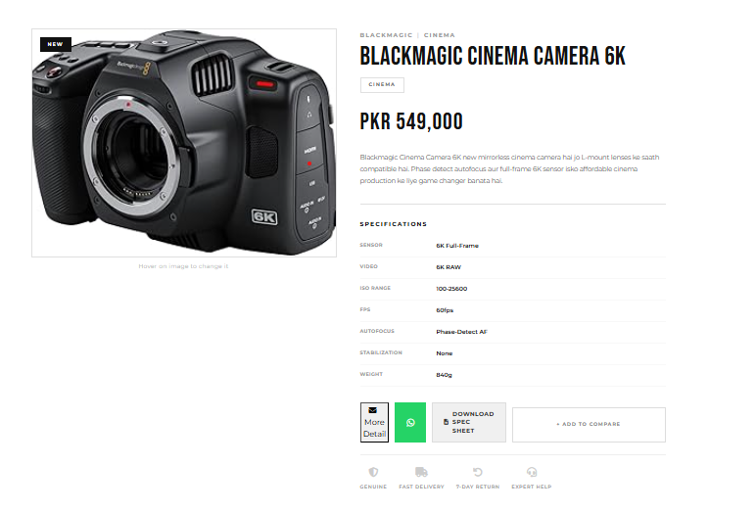
- The information should be categorized according to the brand names of the products like if a User wants to see only “yashica cameras or any other company products then he/she can click on a Link/button/menu etc and can see only that Brand products.
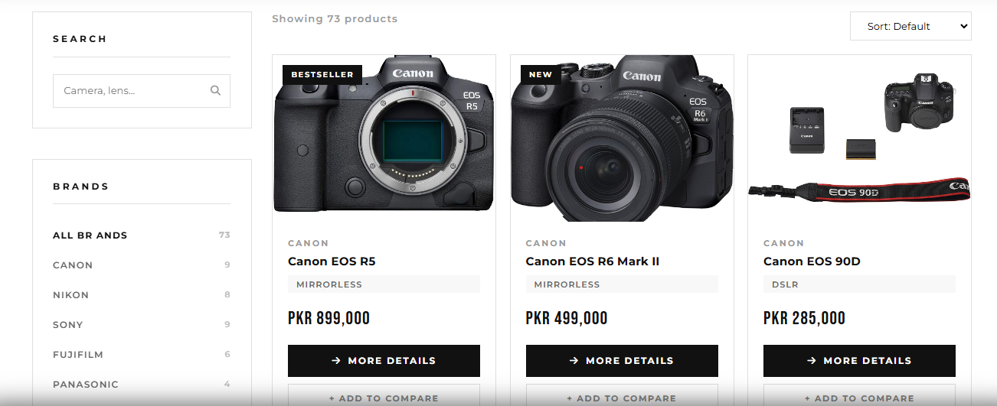
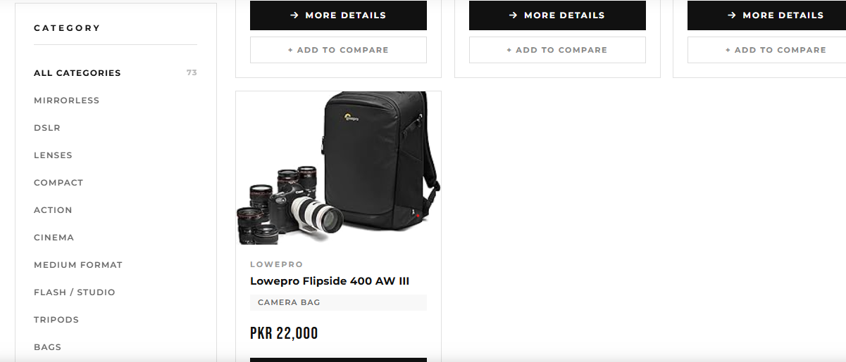

- When a user selects any particular brand, a list of products for that brand will be displayed.
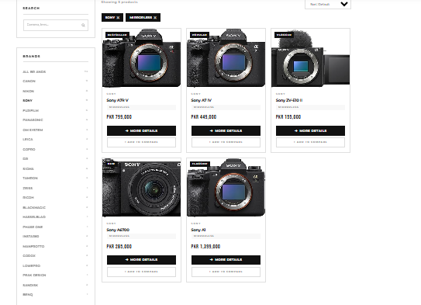
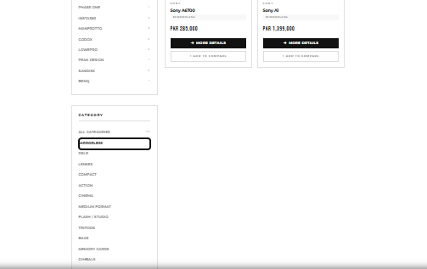
- A brief summary of features of the respective item should be displayed on the Web Page along with the picture but detailed Features should be stored in Individual Word documents which can be downloaded or viewed by the User who wishes to see the same.
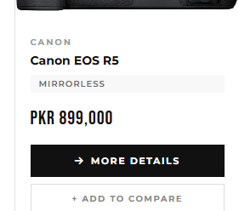
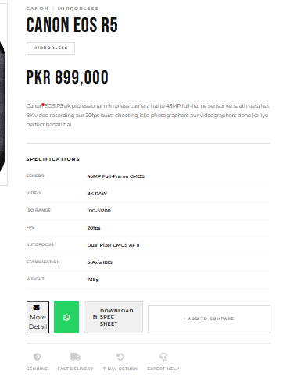
- The user should also be able to compare the various products of different as well as similar brands.
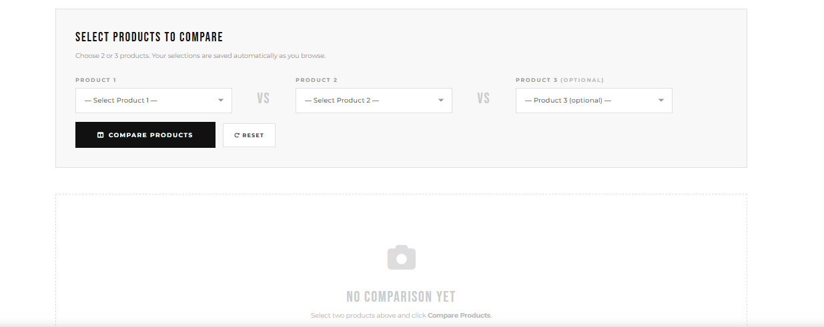
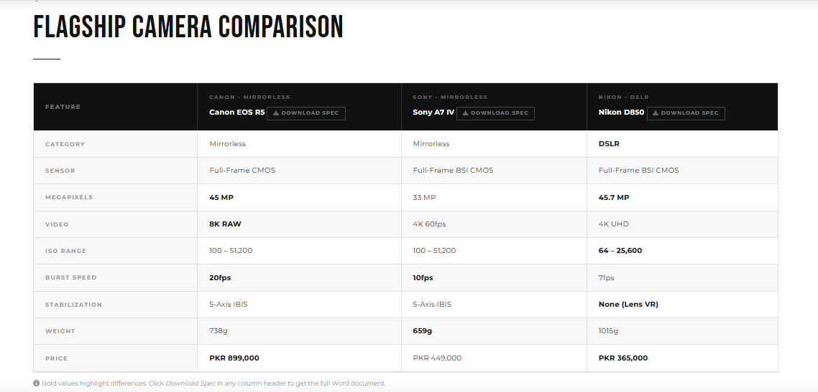
- There should be a Contact Us page which will have the Address of the Company which should be displayed using Geo Location API (Ex. Google Maps) and the email address which when clicked will invoke the local mail client from where they can send an ema

